

**Some Calculation about the Torque**

1, for the 10*25mm Socket Head Cap Screw (Heaviest one)

$M_{total}=1.36kg$ $G=13.328 N$ The angle was set as 45 degree

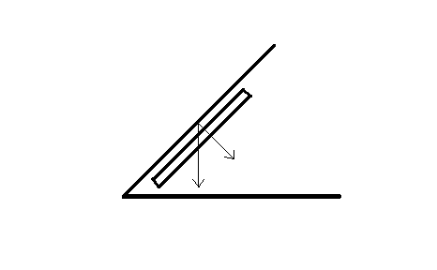So the support force of the plate: $N=G*Sin45=9.424 N$

The friction between the parts and the plate: $f=µ*N=1.4136N$

(All the calculation above ignored the gaps area, and also ignore the friction between the parts and the bowl bottom, because their friction should be cancelled out.)

The Torque that needed: $T=F*r$

It’s hard to decide the radius r, we just set the r biggest, which is r = m

So the torque we need: $T=F*r=1.4136*0.1m=0.14136N*m$

Then the power should be: $P=T*n*η/9549$ ($η=0.8$)

As long as the n is decided (which is r/min) the power P can be calculated.

**The range of the moment of inertia of Plates:**

For the 54mm Screw: $I=0.5463g*m^2$

For the 35mm Screw: $I=1.0709g*m^2$

For the 4mm Nuts: $I=0.3072g*m^2$

For the 10mm Nuts: $I=0.6303g*m^2$

So basically the range of the moment of inertia of plates is:

I: $0.3072g*m^2$ ~ 1.0709g*m^2